2024
Hippology Review 12-15 year old
Source: HORSE & HORSEMANHIP
** Know the part of the: Horse (pg. 8) Bits (Pelham, Bar, Dee Ring) (pg. 30)
All 4 Bridles (pg. 28) All 3 Saddles (pg. 31,32,33)

Pg. 5 1. The grey horse has white hair intermingled with base color and they are born and die the same color.
True or False
Pg. 13 2. ______________is an abnormality which detracts from the appearance of a horse but not its service-ability.

Pg. 13 3. ____________________is an abnormality that interferes with the usefulness of the horse.

Pg. 23 4. Which movement would be most helpful when opening a gate?
- Back B) Sidepass C) Two-tracking

Pg. 24 5. Curb chains mut be at least ________ inches in width and must be ____________ against the chin.

Pg. 32 6. What should a saddle be? Why?

Pg. 39 7. The hair around the ____________________ joint is rimmed to give the legs a neater, cleaner appearance.

Pg. 40 8. What is a combination horse used for?

Pg. 40 9. A race without jumps is called?

Pg. 40 10. What doe Hack mean?

Pg. 47 11. What is laminae?

2024
Hippology Review 12-15 year old

Source: HORSE & HORSEMANHIP
Pg. 48 12. Be able to label the 13 parts of the hook.

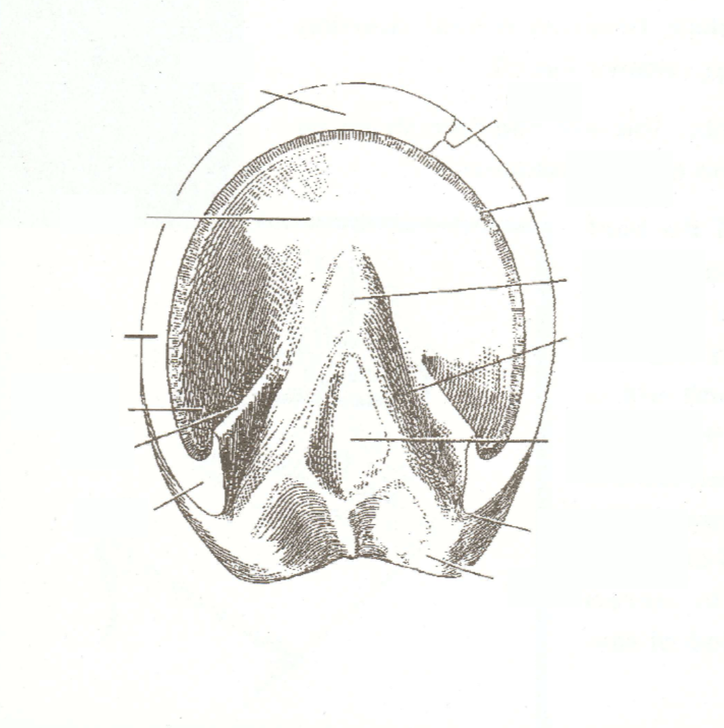

Pg. 51 13. You are to approach a horse from its left and from the front.
True or False
Pg. Appendix B 14. What is a cold-blooded horse?

Pg. 51 15. What are the five basic rules for handling a horse?

Source: 4-H HORSE JUDGING GUIDE
Pg. 3 16. Balance of a horse is achieved when these 5 things look as if the belong to the same horse.

2024
Hippology Review 12-15 year old
Source: 4-H HORSE JUDGING GUIDE
Pg. 3 17 When looking at sex characteristics of horses:
- The stallion should be _____________________________________________________________

- The gelding should be _____________________________________________________________

- The mare should be _______________________________________________________________

Pg. 5 18. When judging the halter horse, which view do you use to determine the style, size, type & balance?

Pg. 17 19. When judging the action of a horse, there are features of the stride to consider. What are they?

Source: EXTERNAL PARASITES OF HORSES
Pg. 8 20. Bots in the digestive tract can cause colic True or False

Pg. 14 21. Does it do any good to apply residual sprays to all areas where adult mosquitoes rest?

Pg. 26 22. What are the two types of lice?

Pg. 26 23. Louse infestations can produce the following:
- Skin irritation C) patchy coat & surface lesions E) all of the above
- Blood loss & anemia D) itching & rubbing

Source: HORSE SCIENCE
Pg. 18 24. What is the sex cell division called?

Pg. 20 25. What is the difference between Genotype an Phenotype?

2024
Hippology Review 12-15 year old
Source: HORSE SCIENCE
Pg. 23 26. Define what Pituitary is?

Pg. 27 27. What is the scientific term for the first stage of digestion?

Pg. 29 28. What are the three regions of the small intestine?

Pg. 50 29. Name the 5 types of colic.

Pg. 52 30. List the 5 most common types of external parasites.

Source: HORSE & PONY RULES & REGULATION
Pg. 1 31. Under what circumstances can a 4H member show a stallion?

Pg. 6 32. The ideal pivot in showmanship requires the horse to turn on the ______________ hind leg.

Pg. 6 33. In showmanship is it ever acceptable to turn your horse to the left (toward you)?

Pg. 10 34. Describe how to mount a horse when in the English Riding Division.

Pg. 18 35. What should be used to score a Dressage test.

Pg. 18 36. What color of breeches are allowed in the Dressage Division?

2024
Hippology Review 12-15 year old
Source: HORSE & PONY RULES & REGULATION
Pg. 19 37. In the Dressage Division, how should direction changes be made?

Pg. 27 38. What is the maximum amount of inches that the riders hands can be held away from the pommel in
Western Snaffle Bit classes?
Pg. 39 39. Wha are the 2 disqualifications for the English/Western Riding pattern.

Pg. 35 40. The ___________ of the horse may also affect the overall appearance in the driving division.

Pg. 37 41. In gymkhana, your horse must be ____________________________________ at all times.

Pg. 38. 42. Barrel Bending is ran around ______________________ barrels.

Pg. 40 43. In _________________________ horse and rider start and end the course completely in the box.

Pg. 45 44. A tie worn at the neck in English Apparel is called ___________________________________________.

Source: HORSE TRAILERING GUIDE
Pg. 2 45. Trailering can pit your horse at a greater risk for illness and injury, especially:

__________________ ,__________________, _________________, __________________.
Pg. 2 46. Even in the best of circumstances, what can be stressful for horses?

Pg. 5 47. What are the most common trailering injuries?

2024
Hippology Review 12-15 year old
Source: PAMPHLET (list below)
Fill in the Blanks
Name of  Illness/Disease | Sleeping Sickness | Rhino | Strangles
How is it Transmitted | biting insects  not horse to horse  not horse to people | 49. | 50.
System/Area it Affects | 51. | respiratory infection  neurological disease  abortion: still birth | 52.
Signs | fever; depression; blindness; head pressing; circling; head tilt; quivering face & leg muscles; paralysis of throat & tongue | 53. | depression: loss of appetite; 104 to 106 degree temperature; cough; nasal discharge; swelling of the lymph nodes of the head & neck
Treatment | 54. | no specific therapy; rest; supportive care | 55.
Prevention | 56. | 57. | vaccination;  quarantine new horses

